1. Q: Draw and label the architecture of a basic artificial neuron (perceptron).
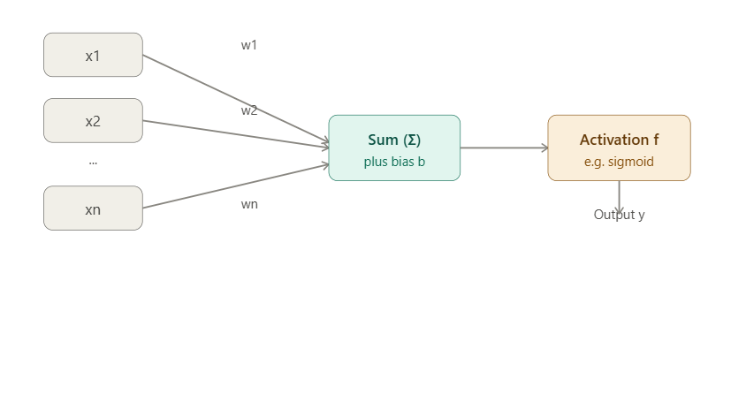
Here's the perceptron diagram — each input xᵢ is multiplied by its weight wᵢ, summed with a bias, passed through an activation function, and produces output y.
2. Q: What is the difference between single-layer and multi-layer neural networks?
A: Single-layer networks have only an input and output layer (no hidden layer) and can solve only linearly separable problems. Multi-layer networks have one or more hidden layers between input and output, allowing them to learn complex, non-linear patterns.
3. Q: Define activation function. List any four commonly used activation functions.
A: An activation function decides whether a neuron should be activated by introducing non-linearity into its output. Four common types: Sigmoid, Tanh, ReLU, Softmax.
4. Q: Write the mathematical formulas for Sigmoid, ReLU, and Tanh activation functions.
A:
- Sigmoid: f(x) = 1 / (1 + e⁻ˣ)
- ReLU: f(x) = max(0, x)
- Tanh: f(x) = (eˣ − e⁻ˣ) / (eˣ + e⁻ˣ)
5. Q: What is Forward Propagation? Briefly explain the computation steps.
A: It is the process of passing input data through the network layer by layer to compute the output. Steps: inputs are multiplied by weights, summed with bias, passed through an activation function, and the result becomes the input for the next layer until the final output is produced.
6. Q: Define Backpropagation. What mathematical principle does it rely on?
A: It is the algorithm used to update weights by propagating the error backward from the output to the input layer. It relies on the chain rule of differential calculus to compute gradients of the loss with respect to each weight.
7. Q: What is a Loss Function? State two commonly used loss functions with their formulas.
A: A loss function measures the difference between the predicted output and the actual target value.
- Mean Squared Error: MSE = (1/n)Σ(yᵢ − ŷᵢ)²
- Binary Cross-Entropy: L = −[y log(ŷ) + (1−y) log(1−ŷ)]
8. Q: What is Gradient Descent? Differentiate between Batch, Mini-batch, and Stochastic variants.
A: It is an optimization algorithm that updates weights in the direction opposite to the gradient of the loss function to minimize error.
- Batch: uses the entire dataset per update.
- Stochastic (SGD): uses one sample per update.
- Mini-batch: uses a small subset (batch) of samples per update.
9. Q: What are the challenges in training neural networks? List any four.
A: Vanishing/exploding gradients, overfitting, high computational cost, and difficulty choosing proper hyperparameters (learning rate, architecture).
10. Q: What is a Feedforward Neural Network (FNN)? Describe its layered structure.
A: An FNN is a network where information flows only in one direction — from input to output — with no cycles. It consists of an input layer, one or more hidden layers, and an output layer, each fully connected to the next.
11. Q: What is an epoch in neural network training?
A: An epoch is one complete pass of the entire training dataset through the neural network during training.
12. Q: What is the role of learning rate in gradient descent?
A: The learning rate controls the size of the steps taken while updating weights during gradient descent. Too high causes overshooting; too low causes slow convergence.
13. Q: Differentiate binary cross-entropy and categorical cross-entropy.
A: Binary cross-entropy is used for two-class (0/1) classification problems, while categorical cross-entropy is used for multi-class classification problems with more than two output classes (usually with Softmax).
14. Q: What is vanishing gradient?
A: It occurs when gradients become extremely small during backpropagation through many layers, causing earlier layers to learn very slowly or stop learning.
15. Q: What is exploding gradient?
A: It occurs when gradients grow excessively large during backpropagation, causing unstable updates and very large weight values.
16. Q: Why is weight initialization important?
A: Proper weight initialization prevents vanishing/exploding gradients and helps the network converge faster and more reliably during training.
17. Q: What is dropout in neural networks?
A: Dropout is a regularization technique where randomly selected neurons are temporarily "dropped" (ignored) during training to prevent overfitting.
18. Q: What is batch normalization?
A: It is a technique that normalizes the inputs of each layer (mean 0, variance 1) to stabilize and speed up training, and reduce sensitivity to initialization.
19. Q: Why is Softmax used in multi-class classification?
A: Softmax converts raw output scores (logits) into probabilities that sum to 1 across all classes, allowing the model to select the class with the highest probability.
20. Q: What is the purpose of an optimizer such as Adam?
A: An optimizer adjusts model weights to minimize the loss function efficiently. Adam combines momentum and adaptive learning rates for faster, more stable convergence than plain gradient descent.
Part-B

1) Explain the architecture of a Feedforward Neural Network with a diagram.

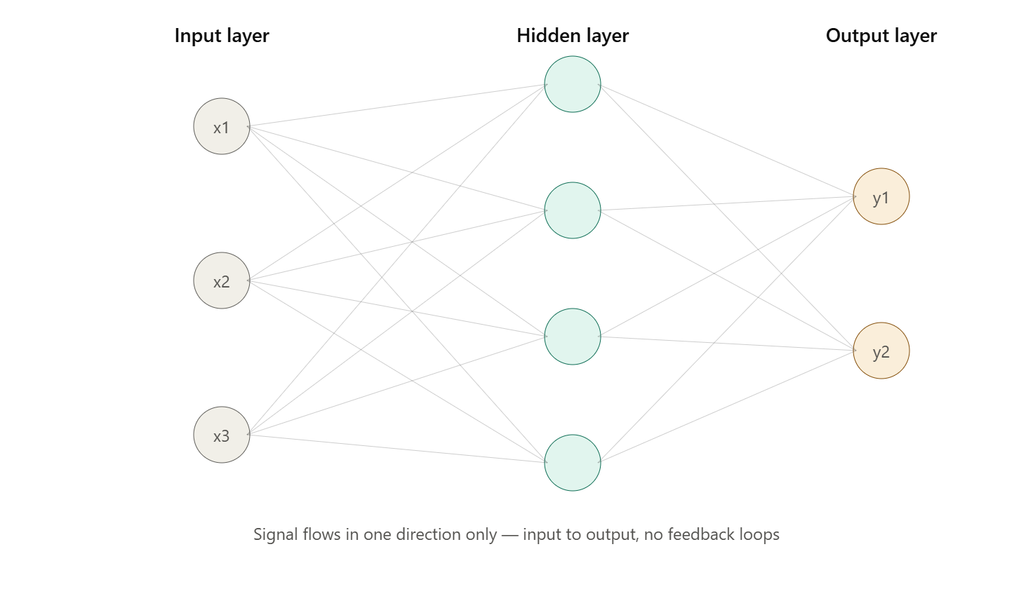

1. Introduction
A Feedforward Neural Network (FNN) is the simplest and most fundamental type of artificial neural network, in which information moves in only one direction — from the input layer, through any hidden layers, to the output layer. There are no cycles, loops, or feedback connections (unlike Recurrent Neural Networks). Because of this strictly forward flow of data, it is called a "feedforward" network. FNNs are the basis of most other deep learning architectures such as CNNs and are widely used for classification and regression tasks. The diagram above illustrates the layered, fully-connected structure described below.
2. Layers of the Architecture
a) Input Layer
- This is the entry point of the network. It does not perform any computation; it simply receives the raw feature values (x1, x2, x3, ..., xn) of the dataset and passes them forward.
- The number of neurons in this layer equals the number of input features.
b) Hidden Layer(s)
- One or more layers positioned between the input and output layers. These layers perform the actual computation and feature extraction.
- Each neuron in a hidden layer receives inputs from every neuron in the previous layer (this is called a "fully connected" or "dense" layer), computes a weighted sum, adds a bias, and applies a non-linear activation function.
- Networks with more than one hidden layer are called Deep Neural Networks (DNNs).
- More hidden layers/neurons allow the network to learn increasingly complex and abstract representations of the data.
c) Output Layer
- The final layer that produces the network's prediction — e.g., class probabilities in classification or a continuous value in regression.
- The number of neurons depends on the task: 1 neuron for binary classification/regression, N neurons for N-class classification.
- Common activation functions here: Sigmoid (binary classification), Softmax (multi-class classification), Linear (regression).
3. Connections and Weights
Every connection between two neurons carries an associated weight (w), which represents the strength/importance of that connection. Each neuron (except input neurons) also has a bias (b) term that shifts the activation threshold. Weights and biases are the learnable parameters of the network — training adjusts them to minimize prediction error.
4. Mathematical Representation
For a single neuron j in a hidden or output layer, receiving inputs x1, x2, ..., xn from the previous layer:
Net input: z = Σ(wᵢxᵢ) + b = w1x1 + w2x2 + ... + wnxn + b
Activation: a = f(z), where f is a non-linear activation function such as Sigmoid, ReLU, or Tanh.
This output "a" then becomes an input to the next layer, and the process repeats layer by layer until the final output layer produces the network's prediction. This layer-by-layer computation is known as forward propagation.
5. Working of the FNN (Step-by-Step)
- Input features are fed into the input layer.
- Each hidden layer neuron computes a weighted sum of its inputs plus bias.
- The result is passed through an activation function to introduce non-linearity.
- The activated outputs are passed forward to the next layer.
- This continues until the output layer produces the final prediction.
- The predicted output is compared to the actual target using a loss function.
- During training, backpropagation and gradient descent are used to adjust the weights and biases to reduce the loss (this happens in the reverse direction, only during training — the forward pass itself is strictly one-directional).
6. Key Characteristics
- Unidirectional flow of information (no cycles or loops).
- Fully connected layers (every neuron connects to every neuron in the adjacent layer, in the standard/dense form).
- Non-linear activation functions enable learning of complex, non-linear relationships.
- Learning occurs via backpropagation + gradient-based optimization.
7. Advantages
- Simple, well-understood architecture — good baseline model.
- Can approximate any continuous function given enough hidden units (Universal Approximation Theorem).
- Works well for structured/tabular data classification and regression tasks.
8. Limitations
- No memory of previous inputs — unsuitable for sequential data (text, time series) — RNNs are used instead.
- Cannot exploit spatial structure in data like images — CNNs are preferred there.
- Fully connected layers can require a large number of parameters, increasing computational cost and risk of overfitting.
9. Applications
Pattern recognition, medical diagnosis systems, credit scoring, basic image/handwriting classification, stock price prediction, and as building blocks within larger deep learning models.
2) Describe Sigmoid, ReLU, Leaky ReLU, Tanh, and Softmax activation functions with their use cases.
Comparison of activation function curves
f(x) by x
SigmoidTanhReLULeaky ReLU
The chart shows how sigmoid and tanh saturate (flatten) at the extremes, while ReLU and Leaky ReLU grow linearly for positive inputs — this is the key distinction behind all their use-case differences below.
Activation Functions — 16 Marks
1. Introduction
An activation function is a mathematical function applied to the weighted sum of inputs at a neuron, introducing non-linearity into the network. Without activation functions, a neural network — no matter how many layers it has — would behave like a single linear model, unable to learn complex patterns. Each activation function has distinct mathematical properties, advantages, drawbacks, and appropriate use cases, described below.
2. Sigmoid Function
Formula: f(x) = 1 / (1 + e⁻ˣ)
Range: (0, 1)
Characteristics:
- S-shaped curve that squashes any real input into a value between 0 and 1.
- Smooth and differentiable everywhere.
Advantages:
- Output can be interpreted as a probability, useful for binary outcomes.
- Smooth gradient, no abrupt jumps.
Disadvantages:
- Suffers from the vanishing gradient problem — for large positive or negative x, the curve flattens and gradients become nearly zero, slowing learning in deep networks.
- Output is not zero-centered, which can slow convergence.
- Computationally more expensive (involves exponentials).
Use cases: Output layer of binary classification models; historically used in hidden layers of shallow networks (rarely used in deep hidden layers today).
3. ReLU (Rectified Linear Unit)
Formula: f(x) = max(0, x)
Range: [0, ∞)
Characteristics:
- Outputs the input directly if positive; outputs zero if negative.
- Simple, computationally efficient (no exponential calculations).
Advantages:
- Avoids vanishing gradient for positive inputs since the gradient is constant (1) there.
- Faster training and convergence compared to sigmoid/tanh.
- Induces sparsity — many neurons output exactly zero, which can improve efficiency.
Disadvantages:
- Dying ReLU problem: neurons that consistently receive negative input get stuck outputting zero permanently, as the gradient there is also zero, so those weights never update again.
- Not zero-centered.
Use cases: Most widely used activation function in hidden layers of deep neural networks and CNNs.
4. Leaky ReLU
Formula: f(x) = x, if x > 0; f(x) = αx, if x ≤ 0 (α is a small constant, typically 0.01)
Range: (−∞, ∞)
Characteristics:
- Similar to ReLU but allows a small, non-zero gradient (α) when the input is negative instead of a hard zero.
Advantages:
- Solves the dying ReLU problem by keeping a small gradient flowing even for negative inputs.
- Retains the computational efficiency and fast convergence of ReLU.
Disadvantages:
- The value of α is a hyperparameter that must be chosen/tuned (or learned in variants like Parametric ReLU).
- Results are not always consistently better than plain ReLU.
Use cases: Deep networks where dying ReLU is a concern; often tried as a drop-in replacement for ReLU in CNNs and deep architectures.
5. Tanh (Hyperbolic Tangent)
Formula: f(x) = (eˣ − e⁻ˣ) / (eˣ + e⁻ˣ)
Range: (−1, 1)
Characteristics:
- S-shaped curve like sigmoid, but zero-centered.
Advantages:
- Zero-centered output helps gradients flow more evenly and generally leads to faster convergence than sigmoid.
- Stronger gradients near zero compared to sigmoid.
Disadvantages:
- Still suffers from vanishing gradients at extreme positive/negative inputs (curve saturates, as seen in the chart above).
- Computationally expensive relative to ReLU.
Use cases: Hidden layers of shallow-to-moderate depth networks; commonly used in Recurrent Neural Networks (RNNs/LSTMs) where zero-centered outputs are beneficial.
6. Softmax Function
Formula: f(xᵢ) = eˣⁱ / Σⱼ eˣʲ (for j = 1 to N classes)
Range: (0, 1), and all outputs sum to 1.
Characteristics:
- Converts a vector of raw scores (logits) into a probability distribution across multiple classes.
- Unlike the other functions, it operates on a vector of outputs jointly, not a single scalar independently.
Advantages:
- Produces interpretable class probabilities.
- Naturally suited for multi-class problems since it highlights the most probable class while keeping all outputs comparable.
Disadvantages:
- Sensitive to outliers/large logit values (though numerically stabilized in practice by subtracting the max logit).
- Only appropriate for the output layer, not hidden layers.
Use cases: Output layer of multi-class classification neural networks (e.g., digit recognition across 10 classes, image classification across many categories), typically paired with categorical cross-entropy loss.
7. Summary Table
Function | Range | Zero-centered | Main issue | Typical use
Sigmoid | (0,1) | No | Vanishing gradient | Binary output layer
Tanh | (−1,1) | Yes | Vanishing gradient | RNN hidden layers
ReLU | [0,∞) | No | Dying ReLU | CNN/DNN hidden layers
Leaky ReLU | (−∞,∞) | No | α tuning needed | Deep nets avoiding dying ReLU
Softmax | (0,1), sums to 1 | No | Only for output layer | Multi-class output layer
3) Given a 2-layer neural network with a specific set of weights, biases, and activation functions, compute the output for a given input by carrying out the forward propagation calculation step by step.

Introduction
Forward propagation is the process of passing an input through the layers of a neural network to calculate the final output.
Consider a 2-layer neural network consisting of:
- Input layer: 2 input neurons
- Hidden layer: 2 neurons
- Output layer: 1 neuron
- Activation function: Sigmoid for hidden and output layers
The sigmoid function is:
$$σ\left(z\right)=\frac{1}{1+e^{-z}}$$
Given Values
Let the input be:
$$X=\left[\begin{matrix}x_{1} \\ x_{2}\end{matrix}\right]=\left[\begin{matrix}1 \\ 2\end{matrix}\right]$$
Weights from Input Layer to Hidden Layer
$$W^{\left(1\right)}=\left[\begin{matrix}0.5 & 0.4 \\ 0.3 & 0.2\end{matrix}\right]$$
Hidden Layer Bias
$$B^{\left(1\right)}=\left[\begin{matrix}0.1 \\ 0.2\end{matrix}\right]$$
Weights from Hidden Layer to Output Layer
$$W^{\left(2\right)}=\left[\begin{matrix}0.7 \\ 0.6\end{matrix}\right]$$
Output Layer Bias
$$B^{\left(2\right)}=0.1$$

Architecture
Input Layer Hidden Layer Output Layer
Input Layer Hidden Layer Output Layer

x₁ = 1 ───────► h₁ ───────►
0.5 0.7
0.3
y
x₂ = 2 ───────► h₂ ───────►
0.4 0.6
0.2

Biases: 0.1, 0.2 Bias: 0.1

Biases: 0.1, 0.2 Bias: 0.1
Step 1 – Calculate Hidden Layer Net Inputs
The net input to a neuron is:
$$z=\sum{w}x+b$$
For Hidden Neuron $h_{1}$
$$z_{1}=x_{1}w_{11}+x_{2}w_{21}+b_{1}$$
Substituting the values:
$$z_{1}=\left(1\right)\left(0.5\right)+\left(2\right)\left(0.3\right)+0.1 \\ z_{1}=0.5+0.6+0.1 \\ \boxed{z_{1}=1.2}$$

For Hidden Neuron $h_{2}$
$$z_{2}=x_{1}w_{12}+x_{2}w_{22}+b_{2} \\ z_{2}=\left(1\right)\left(0.4\right)+\left(2\right)\left(0.2\right)+0.2 \\ z_{2}=0.4+0.4+0.2 \\ \boxed{z_{2}=1.0}$$
Therefore,
$$Z^{\left(1\right)}=\left[\begin{matrix}1.2 \\ 1.0\end{matrix}\right]$$

Step 2 – Apply Activation Function to Hidden Layer
Using the sigmoid function:
$$σ\left(z\right)=\frac{1}{1+e^{-z}}$$
Hidden Neuron $h_{1}$
$$h_{1}=\frac{1}{1+e^{-1.2}} \\ h_{1}≈0.7685$$
Hidden Neuron $h_{2}$
$$h_{2}=\frac{1}{1+e^{-1.0}} \\ h_{2}≈0.7311$$
Therefore, the hidden-layer output is:
$$H=\left[\begin{matrix}0.7685 \\ 0.7311\end{matrix}\right]$$
Step 3 – Calculate Output Layer Net Input
The output neuron receives the outputs of the hidden neurons.
$$z_{o}=h_{1}w_{1}+h_{2}w_{2}+b_{o}$$
Substituting:
$$z_{o}=\left(0.7685\right)\left(0.7\right)+\left(0.7311\right)\left(0.6\right)+0.1$$
Calculate each term:
$$\left(0.7685\right)\left(0.7\right)=0.53795 \\ \left(0.7311\right)\left(0.6\right)=0.43866$$
Therefore,
$$z_{o}=0.53795+0.43866+0.1 \\ \boxed{z_{o}=1.07661}$$

Step 4 – Apply Activation Function at Output
Again using sigmoid:
$$y=\frac{1}{1+e^{-z_{o}}} \\ y=\frac{1}{1+e^{-1.07661}} \\ \boxed{y≈0.746}$$
Therefore, the final output of the neural network is approximately:
$$\boxed{y=0.746}$$
Complete Forward Propagation Calculation
The complete process can be summarized as:
$$\boxed{X→W^{\left(1\right)}X+B^{\left(1\right)}→\text{Sigmoid}→W^{\left(2\right)}H+B^{\left(2\right)}→\text{Sigmoid}→Y}$$
Numerically:
$$\left[\begin{matrix}1 \\ 2\end{matrix}\right]→\left[\begin{matrix}1.2 \\ 1.0\end{matrix}\right]→\left[\begin{matrix}0.7685 \\ 0.7311\end{matrix}\right]→1.07661→\boxed{0.746}$$
Interpretation of the Output
The final output is:
$$\boxed{0.746}$$
If this network is being used for binary classification, a threshold of 0.5 can be used.
$$0.746>0.5$$
Hence, the predicted class is:
Class 1

Algorithm link: https://youtu.be/Tb23YtZ92AE?si=DVH3osdPmho1SYlB
Problem solving Link: https://youtu.be/tUoUdOdTkRw?si=iIB483XxSal-q_UU
**************************************************************************
4) Derive and explain the Backpropagation algorithm using the chain rule.
Backpropagation is an algorithm that trains neural networks by reducing prediction error. It works by propagating errors backward, computing gradients using the chain rule, and updating weights and biases to improve performance.
- Computes gradients of the loss function with respect to each weight using the chain rule
- Updates weights and biases efficiently to reduce error
- Scales well to deep and complex neural networks
- Enables automatic learning and continuous improvement across training iterations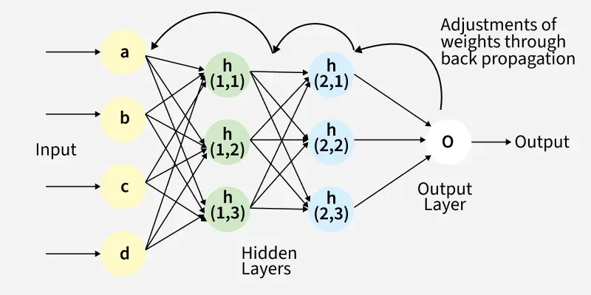
Fig(a) A simple illustration of how the backpropagation works by adjustments of weights

Working of Back Propagation Algorithm
The Back Propagation algorithm involves two main steps:
1. Forward Pass Work
In forward pass, input data moves through the network to generate an output.
- Input data is passed to the input layer and forwarded to hidden layers
- Each neuron computes a weighted sum and adds a bias
- Activation functions (like ReLU) are applied to produce outputs
- Outputs from one layer become inputs to the next layer
- Final layer uses functions like softmax to produce predictions (e.g., probabilities for classification)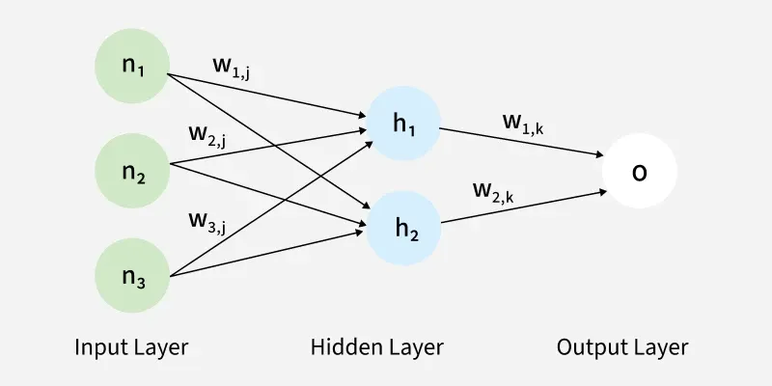
The forward pass using weights and biases

2. Backward Pass
In this step, the error between predicted and actual output is propagated backward to update weights and biases. Error is calculated (e.g., using Mean Squared Error)
$$\text{MSE}={\left(\text{Predicted Output}-\text{Actual Output}\right)}^{2}$$
- Gradients are computed using the chain rule
- Weights and biases are updated to reduce the error
- Process continues layer by layer from output to input
- Derivatives of activation functions are used to compute gradients effectively
Example
Let’s walk through an example of Back Propagation in machine learning. Assume the neurons use the sigmoid activation function for the forward and backward pass. The target output is 0.5 and the learning rate is 1.
Forward Propagation
1. Initial Calculation
The weighted sum at each node is calculated using:
$$aj\text{​}=\sum{(}\left.w , i\text{​}j*xi\text{​}\right)$$
Where,
- $a_{j}$ is the weighted sum of all the inputs and weights at each node
- $w_{i,j}$ represents the weights between the $i^{th}$input and the $j^{th}$ neuron
- $x_{i}$ represents the value of the $i^{th}$ input
O (output): After applying the activation function to a, we get the output of the neuron:
$o_{j}$= activation function($a_{j}$)
2. Sigmoid Function
The sigmoid function returns a value between 0 and 1, introducing non-linearity into the model.
$$y_{j}=\frac{1}{1+e^{-a_{j}}}$$
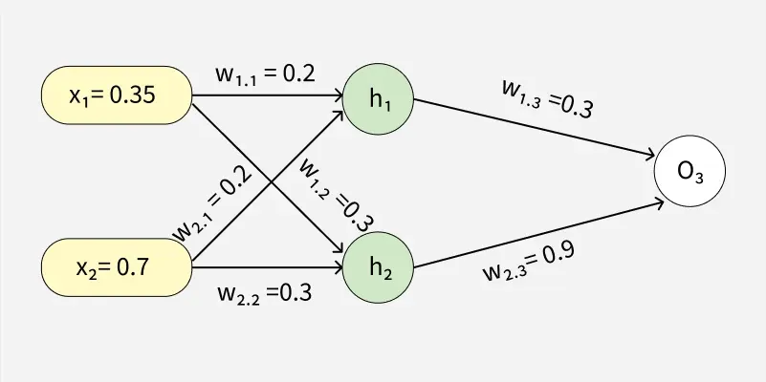
Example (1) of backpropagation sum

To find the outputs of y3, y4 and y5

3. Computing Outputs
At h1 node
$$\begin{aligned}a_{1}&=\left(w_{1,1}x_{1}\right)+\left(w_{2,1}x_{2}\right) \\ &=\left(0.2*0.35\right)+\left(0.2*0.7\right) \\ &=0.21\end{aligned}$$
Once we calculated the a₁ value, we can now proceed to find the y₃ value:
$$y_{j}=F\left(a_{j}\right)=\frac{1}{1+e^{-a_{1}}}$$
$$y_{3}=F\left(0.21\right)=\frac{1}{1+e^{-0.21}}$$
$$y_{3}=0.56$$
Similarly find the values of y₄ at h2 and y₅ at O₃
$$a_{2}=\left(w_{1,2}*x_{1}\right)+\left(w_{2,2}*x_{2}\right)=\left(0.3*0.35\right)+\left(0.3*0.7\right)=0.315$$

$$y_{4}=F\left(0.315\right)=\frac{1}{1+e^{-0.315}}$$

$$a3=\left(w_{1,3}*y_{3}\right)+\left(w_{2,3}*y_{4}\right)=\left(0.3*0.57\right)+\left(0.9*0.59\right)=0.702$$

$$y_{5}=F\left(0.702\right)=\frac{1}{1+e^{-0.702}}=0.67$$

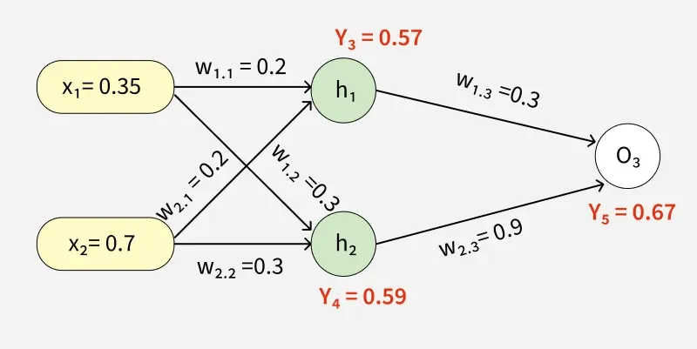
4. Error Calculation
Our actual output is 0.5 but we obtained 0.67. To calculate the error we can use the below formula:
$$Error_{j}=y_{target}-y_{5}$$
$$\text{=> }0.5-0.67=-0.17$$
Using this error value we will be backpropagating.
Back Propagation
1. Calculating Gradients
The change in each weight is calculated as:
$$Δw_{ij}=η×δ_{j}×O_{j}$$
Where:
- $δ_{j}$​ is the error term for each unit,
- $η$ is the learning rate.
2. Output Unit Error
For O3:
$$δ_{5}=y_{5}\left(1-y_{5}\right)\left(y_{target}-y_{5}\right)$$
$$=0.67\left(1-0.67\right)\left(-0.17\right)=-0.0376$$
3. Hidden Unit Error
For h1:
$$δ_{3}=y_{3}\left(1-y_{3}\right)\left(w_{1,3}×δ_{5}\right)$$
$$=0.56\left(1-0.56\right)\left(0.3×-0.0376\right)=-0.0027$$
For h2:
$$δ_{4}=y_{4}\left(1-y_{4}\right)\left(w_{2,3}×δ_{5}\right)$$
$$=0.59\left(1-0.59\right)\left(0.9×-0.0376\right)=-0.00819$$
4. Weight Updates
For the weights from hidden to output layer:
$$Δw_{2,3}=1×\left(-0.0376\right)×0.59=-0.022184$$
New weight:
$$w_{2,3}\left(\text{new}\right)=-0.022184+0.9=0.877816$$
For weights from input to hidden layer:
$$Δw_{1,1}=1×\left(-0.0027\right)×0.35=-0.000945$$
New weight:
$$w_{1,1}\left(\text{new}\right)=-0.000945+0.2=0.199055$$
Similarly other weights are updated:
- $w_{1,2}\left(\text{new}\right)=0.273225$
- $w_{1,3}\left(\text{new}\right)=0.086615$
- $w_{2,1}\left(\text{new}\right)=0.269445$
- $w_{2,2}\left(\text{new}\right)=0.18534$
The updated weights are illustrated below

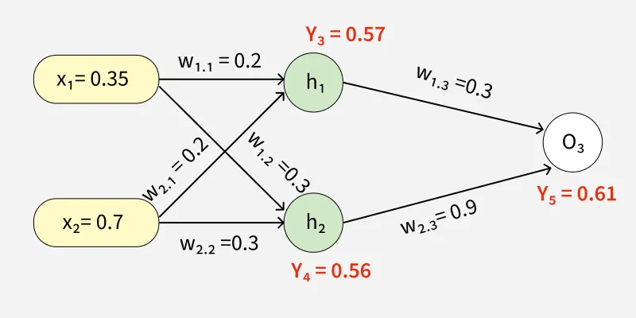
Through backward pass the weights are updated
After updating the weights the forward pass is repeated hence giving:
- $y_{3}=0.57$
- $y_{4}=0.56$
- $y_{5}=0.61$
Since $y_{5}=0.61$ is still not the target output the process of calculating the error and backpropagating continues until the desired output is reached.
This process demonstrates how Back Propagation iteratively updates weights by minimizing errors until the network accurately predicts the output.
$$Error=y_{target}-y_{5}$$
$$=0.5-0.61=-0.11$$
This process is said to be continued until the actual output is gained by the neural network.
Problem solving link: https://youtu.be/tUoUdOdTkRw?si=iI87JcFdSY4YqvGF
*********************************************************************
5) A neural network trained for image classification shows high training accuracy but poor validation accuracy.Interpret the possible causes and recommend suitable remedies.
A neural network used for image classification may sometimes achieve very high accuracy on the training dataset but perform poorly on the validation dataset. This situation is mainly an indication of overfitting. Overfitting occurs when the neural network learns the training images and their specific patterns too closely, including noise and irrelevant details, instead of learning general features that are useful for classifying new images. As a result, the model performs very well on images that it has already seen during training but fails to classify unseen validation images correctly.
One major cause is that the network may be too complex for the available training data. A deep neural network with a large number of layers, neurons, and parameters has a high learning capacity. If the training dataset is small, the model can memorize the training images rather than learning general features. For example, if only a few hundred images are available but the network contains millions of parameters, the model can easily fit the training data. A suitable remedy is to reduce the model complexity by using fewer layers or neurons. Alternatively, a larger and more diverse training dataset can be collected.
Another important cause is a small or insufficiently diverse training dataset. If the training images do not represent the variations found in real-world images, the network cannot generalize properly. For example, an image-classification model trained mainly on clear images may perform poorly when validation images contain different lighting, orientations, backgrounds, or image sizes. This problem can be reduced by collecting more representative images and using data augmentation techniques such as rotation, flipping, cropping, scaling, translation, and brightness adjustment. Data augmentation creates additional variations of training images and helps the model learn more general features.
Lack of regularization can also cause high training accuracy and low validation accuracy. Regularization prevents the model from becoming excessively dependent on particular training samples. Common methods include L1 regularization, L2 regularization, dropout, and early stopping. In dropout, some neurons are randomly ignored during training, forcing the network to learn distributed and robust features instead of depending on a small number of neurons. L2 regularization penalizes excessively large weights and encourages the network to learn simpler patterns.
Another possible reason is that the model may be trained for too many epochs. During the early stages of training, both training and validation accuracy generally improve. After a certain point, the training accuracy may continue increasing while validation accuracy starts decreasing. This indicates that the network has started memorizing the training data. Early stopping can be used to stop training when the validation performance stops improving. The model weights corresponding to the best validation performance can be saved and used as the final model.
The training and validation datasets may also have a distribution mismatch. If the training images and validation images are significantly different, the model may learn patterns specific to the training dataset. For example, training images may have a particular background or image quality, whereas validation images may have different backgrounds and lighting conditions. Therefore, the training and validation datasets should be prepared using similar preprocessing methods and should represent the same type of real-world data.
Another cause may be incorrect data preprocessing. Images used for training and validation should undergo consistent preprocessing, such as resizing, normalization, and pixel-value scaling. If training images are normalized but validation images are not, the network receives inputs with different distributions. This can significantly reduce validation performance. Therefore, the same preprocessing pipeline should be applied to both training and validation data, while data augmentation should normally be applied only to the training data.
Class imbalance can also affect validation performance. If some classes have many more training images than others, the network may become biased toward the majority classes. It may therefore show high overall training accuracy while performing poorly on minority classes. Suitable remedies include collecting more samples for minority classes, applying class weights, using balanced sampling, and evaluating the model using metrics such as precision, recall, F1-score, and confusion matrix, rather than relying only on accuracy.
A suitable approach is also transfer learning. Instead of training a large image-classification network completely from the beginning, a pretrained CNN such as ResNet, EfficientNet, or MobileNet can be used. The pretrained model has already learned useful general image features such as edges, textures, and shapes. The final classification layers can then be adapted to the required classes. This is particularly useful when the available dataset is small.
Remedies Summary
Problem | Suitable Remedy
Model too complex | Reduce layers/neurons
Small dataset | Collect more training images
Lack of image variation | Data augmentation
No regularization | Dropout, L1/L2 regularization
Too many training epochs | Early stopping
Training/validation mismatch | Use representative datasets
Different preprocessing | Apply consistent preprocessing
Class imbalance | Class weights/balanced sampling
Limited training data | Transfer learning
Poor evaluation | Use confusion matrix, precision, recall and F1-score

6) A deep network for stock trend prediction is learning very slowly and suffers from unstable gradients. Explain how activation choice, initialization, normalization, and optimization can address the issue.
A deep neural network used for stock trend prediction may learn very slowly and suffer from unstable gradients, especially when the network contains many hidden layers. During training, gradients are propagated backward from the output layer to the earlier layers. If these gradients become extremely small, the network suffers from the vanishing gradient problem and learns very slowly. If they become extremely large, the network suffers from the exploding gradient problem, causing unstable training. These problems can be reduced by choosing suitable activation functions, weight initialization methods, normalization techniques, and optimization algorithms.
1. Choice of Activation Function
The choice of activation function has a major effect on gradient flow. Traditional sigmoid and tanh functions can suffer from vanishing gradients because their derivatives become very small when the input is very large or very small. When many layers use these functions, the small gradients are multiplied repeatedly during backpropagation, causing the gradients reaching the earlier layers to become almost zero. Therefore, for hidden layers, ReLU (Rectified Linear Unit) is generally preferred:
$$ReLU\left(x\right)=max⁡\left(0 , x\right)$$
ReLU has a derivative of 1 for positive inputs, which helps gradients flow more effectively through deep networks. However, ReLU can produce zero outputs for negative inputs, leading to the dying ReLU problem. To reduce this problem, variants such as Leaky ReLU, ELU, or GELU can be used. For example:
$$LeakyReLU\left(x\right)=\left\{\begin{matrix}x, & x>0 \\ αx, & x≤0\end{matrix}\right.$$
For a stock trend classification problem, a sigmoid function can be retained in the final output layer when there are two classes such as up and down, because it produces an output between 0 and 1.

2. Proper Weight Initialization
Poor initialization of weights can also cause unstable gradients. If the initial weights are too large, activations and gradients can become extremely large, producing exploding gradients. If the weights are too small, the activations and gradients can become very small, producing vanishing gradients.
Therefore, weights should be initialized using methods suitable for the selected activation function. For ReLU-based networks, He initialization is commonly used:
$$W∼N\left(0 , \frac{2}{n_{in}}\right)$$
where $n_{in}$is the number of input connections to the neuron.
For sigmoid or tanh activation functions, Xavier/Glorot initialization is commonly used:
$$W∼N\left(0 , \frac{2}{n_{in}+n_{out}}\right)$$
These initialization methods keep the variance of activations reasonably stable from one layer to another and improve gradient flow during training.

3. Normalization
Normalization techniques help maintain stable values of activations throughout the network. Batch Normalization is a commonly used method. It normalizes the activations of a layer using the mean and variance of a mini-batch.
The basic normalization is:
$$\hat{x}=\frac{x-μ_{B}}{\sqrt{σ_{B}^{2}+ϵ}}$$
It is then scaled and shifted:
$$y=γ\hat{x}+β$$
where $γ$and $β$are learnable parameters.
Batch normalization can make training more stable and often allows the use of a larger learning rate. For sequential stock data, however, care must be taken to avoid using information from future observations. Layer Normalization can also be useful, particularly in recurrent or sequence-based networks, because it normalizes across features within an individual sample rather than relying on batch statistics.
Input features should also be appropriately scaled. Stock-related features such as price, trading volume, moving averages, and technical indicators can have very different ranges. Standardization can be performed using:
$$x^{'}=\frac{x-μ}{σ}$$
This prevents features with large numerical values from dominating the learning process.

4. Suitable Optimization Algorithm
The optimization algorithm determines how the weights are updated based on the calculated gradients. Basic gradient descent uses:
$$W_{new}=W_{old}-η\frac{∂L}{∂W}$$
where $η$is the learning rate.
If the learning rate is too small, the network learns very slowly. If it is too large, the training process may oscillate or diverge. Therefore, a suitable learning rate must be selected.
Adaptive optimizers such as Adam can be used to improve learning. Adam maintains estimates of the first and second moments of the gradients and automatically adapts the learning rate for individual parameters. It is often effective for deep networks and noisy optimization problems such as stock prediction.
The Adam updates can be represented as:
$$m_{t}=β_{1}m_{t-1}+\left(1-β_{1}\right)g_{t} \\ v_{t}=β_{2}v_{t-1}+\left(1-β_{2}\right)g_{t}^{2}$$
and the parameters are updated using:
$$θ_{t}=θ_{t-1}-η\frac{{\hat{m}}_{t}}{\sqrt{{\hat{v}}_{t}}+ϵ}$$
Thus, Adam can provide faster and more stable convergence than basic gradient descent.

5. Gradient Clipping
When gradients become extremely large, gradient clipping can be used to prevent exploding gradients. If the gradient norm exceeds a specified threshold, the gradient is scaled down:
$$g^{'}=g\frac{τ}{∣∣g∣∣}$$
when:
$$∣∣g∣∣>τ$$
where $τ$is the maximum allowed gradient norm.
This is particularly useful in deep or recurrent networks used for stock time-series prediction.

6. Learning Rate Scheduling
The learning rate can also be changed during training. Initially, a relatively larger learning rate can help the model learn quickly. Later, the learning rate can be reduced to allow the model to make smaller and more precise updates.
Methods such as learning-rate decay, ReduceLROnPlateau, cosine decay, or warm-up schedules can be used. If validation loss stops improving, the learning rate can be reduced. This helps the network converge more smoothly.

7. Recommended Combination
For the given stock trend prediction problem, a suitable solution would be:
Problem | Suitable Technique
Vanishing gradients | ReLU/Leaky ReLU, proper initialization
Exploding gradients | Gradient clipping
Poor weight scale | He or Xavier initialization
Unstable activations | Batch/Layer Normalization
Different feature ranges | Feature standardization
Slow learning | Adam optimizer
Oscillating training | Reduce learning rate
Training becomes stagnant | Learning-rate scheduling
Binary stock trend output | Sigmoid output layer

7) Using a dataset of your choice, implement MSE, Cross-Entropy, and Hinge Loss functions. Compute the corresponding loss values and gradients, analyze the results, and compare the suitability of each loss function for regression and classification tasks.
1. Introduction
A loss function measures the difference between the actual target value and the value predicted by a machine-learning model. During training, the model tries to minimize this loss by adjusting its weights using the calculated gradients.
In this example, two small datasets are considered:
- Regression dataset: Actual and predicted continuous values are used to demonstrate Mean Squared Error (MSE).
- Binary classification dataset: Actual class labels and predicted scores are used to demonstrate Cross-Entropy Loss and Hinge Loss.

2. MSE Loss for Regression
Consider the following regression dataset:
Sample | Actual $y$ | Predicted $\hat{y}$
1 | 3 | 2.5
2 | 5 | 4.0
3 | 7 | 8.0
4 | 9 | 8.5
The Mean Squared Error is:
$$MSE=\frac{1}{n}\sum_{i=1}^{n}{(}\left.y_{i}-{\hat{y}}_{i}{\left.)\right.}^{2}\right.$$
For the given data:
$$MSE=\frac{1}{4}\left[{\left(3-2.5\right)}^{2}+{\left(5-4\right)}^{2}+{\left(7-8\right)}^{2}+{\left(9-8.5\right)}^{2}\right] \\ =\frac{1}{4}\left[0.25+1+1+0.25\right] \\ =\frac{2.5}{4} \\ \boxed{MSE=0.625}$$
Gradient of MSE
The derivative with respect to prediction ${\hat{y}}_{i}$is:
$$\boxed{\frac{∂MSE}{∂{\hat{y}}_{i}}=\frac{2}{n}\left({\hat{y}}_{i}-y_{i}\right)}$$
For the four samples:
$$\frac{∂MSE}{∂\hat{y}}=\left[\begin{matrix}-0.25 \\ -0.50 \\ 0.50 \\ -0.25\end{matrix}\right]$$
The gradients indicate the direction in which the predicted values should be changed to reduce the error.

3. Cross-Entropy Loss for Classification
For binary classification, consider:
Sample | Actual $y$ | Predicted Probability $p$
1 | 1 | 0.9
2 | 1 | 0.8
3 | 0 | 0.3
4 | 0 | 0.2
Binary Cross-Entropy is:
$$CE=-\frac{1}{n}\sum_{i=1}^{n}{[}\left.y_{i}log⁡\left(p_{i}\right)+\left(1-y_{i}\right)log⁡\left(1-p_{i}\right)\right]$$
Substituting the values:
$$CE=-\frac{1}{4}\left[log⁡\left(0.9\right)+log⁡\left(0.8\right)+log⁡\left(0.7\right)+log⁡\left(0.8\right)\right]$$
Therefore:
$$CE≈\boxed{0.207}$$
The loss is relatively small because the predicted probabilities are reasonably close to the correct classes.
Gradient of Cross-Entropy
When Cross-Entropy is combined with a sigmoid output, the gradient with respect to the prediction probability is:
$$\boxed{\frac{∂CE}{∂p}=\frac{p-y}{p\left(1-p\right)n}}$$
For a sigmoid output $p=σ\left(z\right)$, the gradient with respect to the logit $z$simplifies to:
$$\boxed{\frac{∂CE}{∂z}=\frac{p-y}{n}}$$
For the four samples:
$$\frac{∂CE}{∂z}=\left[\begin{matrix}-0.025 \\ -0.050 \\ 0.075 \\ 0.050\end{matrix}\right]$$
These gradients are used to update the neural-network weights.

4. Hinge Loss for Classification
Hinge loss is commonly associated with Support Vector Machines (SVMs). It is generally used with labels represented as:
$$y∈\left\{- , 1+1\right\}$$
Consider the following data:
Sample | Actual $y$ | Model Score $f\left(x\right)$
1 | +1 | 1.5
2 | +1 | 0.5
3 | -1 | -0.5
4 | -1 | -2.0
The hinge loss is:
$$L=max⁡\left(0 , 1-yf\left(x\right)\right)$$
Sample 1
$$L=max⁡\left(0 , 1-\left(1\right)\left(1.5\right)\right) \\ =max⁡\left(0 , -0.5\right)=0$$
Sample 2
$$L=max⁡\left(0 , 1-\left(1\right)\left(0.5\right)\right) \\ =max⁡\left(0 , 0.5\right)=0.5$$
Sample 3
$$L=max⁡\left(0 , 1-\left(-1\right)\left(-0.5\right)\right) \\ =max⁡\left(0 , 0.5\right)=0.5$$
Sample 4
$$L=max⁡\left(0 , 1-\left(-1\right)\left(-2\right)\right) \\ =max⁡\left(0 , -1\right)=0$$
Therefore:
$$Hinge Loss=\frac{0+0.5+0.5+0}{4} \\ \boxed{Hinge Loss=0.25}$$

5. Gradient of Hinge Loss
For:
$$L=max⁡\left(0 , 1-yf\left(x\right)\right)$$
the gradient with respect to the model score $f\left(x\right)$is:
$$\frac{∂L}{∂f\left(x\right)}=\left\{\begin{matrix}-y, & yf\left(x\right)<1 \\ 0, & yf\left(x\right)>1\end{matrix}\right.$$
At $yf\left(x\right)=1$, the loss is not differentiable, so a subgradient is used.
For the given samples:
- Sample 1: $yf\left(x\right)=1.5>1$, gradient = 0
- Sample 2: $yf\left(x\right)=0.5<1$, gradient = $-1$
- Sample 3: $yf\left(x\right)=0.5<1$, gradient = $+1$
- Sample 4: $yf\left(x\right)=2>1$, gradient = 0
Thus:
$$\boxed{\frac{∂L}{∂f\left(x\right)}=\left[0 , - , 1 , +10\right]}$$
The average gradient is:
$$\boxed{0}$$
although individual samples still contribute to the learning process.

6. Python Implementation
The three loss functions can be implemented easily using Python.
import numpy as np

# -------------------------------
# 1. MSE Loss
# -------------------------------
y_reg = np.array([3, 5, 7, 9])
pred_reg = np.array([2.5, 4, 8, 8.5])

mse = np.mean((y_reg - pred_reg) ** 2)
mse_gradient = (2 / len(y_reg)) * (pred_reg - y_reg)

print("MSE Loss:", mse)
print("MSE Gradient:", mse_gradient)

# -------------------------------
# 2. Cross-Entropy Loss
# -------------------------------
y_cls = np.array([1, 1, 0, 0])
prob = np.array([0.9, 0.8, 0.3, 0.2])

ce = -np.mean(
y_cls * np.log(prob) +
(1 - y_cls) * np.log(1 - prob)
)

ce_gradient = (prob - y_cls) / len(y_cls)

print("\nCross-Entropy Loss:", ce)
print("Cross-Entropy Gradient:", ce_gradient)

# -------------------------------
# 3. Hinge Loss
# -------------------------------
y_hinge = np.array([1, 1, -1, -1])
score = np.array([1.5, 0.5, -0.5, -2])

hinge = np.maximum(0, 1 - y_hinge * score)
hinge_loss = np.mean(hinge)

hinge_gradient = np.where(
y_hinge * score < 1,
-y_hinge / len(y_hinge),
0
)

print("\nHinge Loss:", hinge_loss)
print("Hinge Gradient:", hinge_gradient)
Expected Output
MSE Loss: 0.625
MSE Gradient: [-0.25 -0.5 0.5 -0.25]

Cross-Entropy Loss: 0.207...
Cross-Entropy Gradient: [-0.025 -0.05 0.075 0.05 ]

Hinge Loss: 0.25
Hinge Gradient: [ 0. -0.25 0.25 0. ]

7. Analysis of Results
The MSE loss is 0.625, which represents the average squared difference between actual and predicted continuous values. It is highly suitable for regression problems, where the output is a continuous numerical value such as house price, temperature, sales, or demand. However, MSE is not normally the best choice for classification because it does not directly model class probabilities and may provide less suitable gradients when combined with classification outputs.
The Cross-Entropy loss is approximately 0.207, indicating that the predicted probabilities are reasonably close to the actual classes. Cross-Entropy is highly suitable for classification problems, especially when the model produces probabilities using sigmoid or softmax activation. It strongly penalizes confident but incorrect predictions and generally provides effective gradients for training neural networks.
The Hinge loss is 0.25 for the given classification scores. Hinge loss focuses on whether the prediction satisfies a required classification margin. Correct predictions that are sufficiently far from the decision boundary have zero loss. It is therefore particularly suitable for SVM-based classification. Unlike Cross-Entropy, hinge loss does not naturally produce probability values.

8. Comparison of Loss Functions
Feature | MSE | Cross-Entropy | Hinge Loss
Full form | Mean Squared Error | Cross-Entropy Loss | Hinge Loss
Main use | Regression | Classification | Classification
Output type | Continuous value | Probability | Class score
Typical labels | Numerical | 0/1 or class indices | -1/+1
Formula | $$\frac{1}{n}\sum{(}\left.y-\hat{y}{\left.)\right.}^{2}\right.$$ | $$-\left[y\log{p}+\left(1-y\right)log⁡\left(1-p\right)\right]$$ | $$max⁡\left(0 , 1-yf\left(x\right)\right)$$
Common model | Linear/Neural network | Logistic regression/Neural network | SVM
Probability output | No | Yes | No
Margin-based | No | No | Yes
Suitable for regression | Excellent | No | No
Suitable for classification | Limited | Excellent | Excellent for margin-based models

9. Suitability
MSE is the most appropriate among the three for regression tasks because it directly measures the squared difference between the predicted and actual continuous values. It is differentiable and can be easily optimized using gradient descent.
Cross-Entropy is generally the preferred loss for neural-network classification. For binary classification, it is normally combined with a sigmoid output, while for multi-class classification it is commonly combined with softmax. It gives strong learning signals when the model is confidently wrong.
Hinge Loss is particularly suitable for SVM classification, where the objective is to create a decision boundary with a suitable margin. It concentrates on incorrectly classified samples and correctly classified samples that are too close to the decision boundary.
8) Implement a simple neural network for the XOR problem with forward and backward pass.
. Introduction
The XOR (Exclusive OR) problem is a well-known example used to demonstrate the need for a multi-layer neural network. A single-layer perceptron cannot solve XOR because the data is not linearly separable. A neural network with one hidden layer can solve the problem using forward propagation and backpropagation.
The XOR truth table is:
$$X_{1}$$ | $$X_{2}$$ | Target $Y$
0 | 0 | 0
0 | 1 | 1
1 | 0 | 1
1 | 1 | 0

2. Network Architecture
Consider a network with:
- 2 input neurons
- 2 hidden neurons
- 1 output neuron
- Sigmoid activation function
- Backpropagation for training
Input Layer Hidden Layer Output Layer

X1 ───────► H1 ────────┐
╲ │
╲ ▼
► H2 ────► Y
╱
X2 ───────►

2 neurons 2 neurons 1 neuron
The sigmoid activation function is:
$$σ\left(x\right)=\frac{1}{1+e^{-x}}$$
Its derivative is:
$$σ^{'}\left(x\right)=σ\left(x\right)\left(1-σ\left(x\right)\right)$$
3. Python Implementation
The following program implements the XOR neural network without using a machine-learning library, so that the forward pass, error calculation, backward pass, and weight updates can be clearly understood.
import numpy as np

# XOR input and target
X = np.array([
[0, 0],
[0, 1],
[1, 0],
[1, 1]
])

Y = np.array([
[0],
[1],
[1],
[0]
])

# Sigmoid activation function
def sigmoid(x):
return 1 / (1 + np.exp(-x))

# Derivative of sigmoid
def sigmoid_derivative(x):
return x * (1 - x)

# Random weight initialization
np.random.seed(42)

# Input -> Hidden weights
W1 = np.random.randn(2, 2)

# Hidden layer bias
b1 = np.zeros((1, 2))

# Hidden -> Output weights
W2 = np.random.randn(2, 1)

# Output bias
b2 = np.zeros((1, 1))

learning_rate = 0.5

# Training
for epoch in range(10000):

# -------------------------
# FORWARD PASS
# -------------------------

# Hidden layer
Z1 = np.dot(X, W1) + b1
A1 = sigmoid(Z1)

# Output layer
Z2 = np.dot(A1, W2) + b2
A2 = sigmoid(Z2)

# -------------------------
# ERROR
# -------------------------

error = Y - A2

# -------------------------
# BACKWARD PASS
# -------------------------

# Output layer gradient
dA2 = error * sigmoid_derivative(A2)

# Hidden -> Output gradient
dW2 = np.dot(A1.T, dA2)
db2 = np.sum(dA2, axis=0, keepdims=True)

# Hidden layer gradient
dA1 = np.dot(dA2, W2.T)
dZ1 = dA1 * sigmoid_derivative(A1)

# Input -> Hidden gradient
dW1 = np.dot(X.T, dZ1)
db1 = np.sum(dZ1, axis=0, keepdims=True)

# -------------------------
# UPDATE WEIGHTS
# -------------------------

W2 = W2 + learning_rate * dW2
b2 = b2 + learning_rate * db2

W1 = W1 + learning_rate * dW1
b1 = b1 + learning_rate * db1

# -------------------------
# TEST THE NETWORK
# -------------------------

Z1 = np.dot(X, W1) + b1
A1 = sigmoid(Z1)

Z2 = np.dot(A1, W2) + b2
output = sigmoid(Z2)

print("Predicted Output:")
print(output)

print("\nPredicted Class:")
print((output > 0.5).astype(int))

Expected Output
After sufficient training, the network produces outputs approximately like:
Input Target Predicted Output
-------------------------------------------
0 0 0 0.01
0 1 1 0.98
1 0 1 0.98
1 1 0 0.02
Using a threshold of 0.5:
Predicted Class:

0
1
1
0
Therefore:
$$\boxed{XOR\left(0 , 0\right)=0} \\ \boxed{XOR\left(0 , 1\right)=1} \\ \boxed{XOR\left(1 , 0\right)=1}$$

Explanation Link: https://youtu.be/xeSqeMPMb-0?si=MOzNPMHnCU_wbH4D
*********************************************************

